**Worksheet 5**

## **Student Name:** Rohit Gorai **UID:**25MCA20093

## **Branch:** MCA (General) **Section/Group:** 25MCA-2A

## **Semester:** 1st **Date of Performance:**24-10-2025

## **Subject Name:** PL/SQL Lab **Subject Code:** 25CAP-602

## 

1. **Aim/Overview of the practical:** longest CITY names, as well as their respective lengths (i.e.: number of characters in the name). If there is more than one smallest or largest city, choose  the  one  that  comes  first  when  ordered  alphabetically. The STATION table is described as follows:

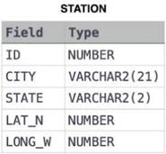

where LAT_N is the northern latitude and LONG_W is the western longitude***.***

1. **Task to be done:**
2. Create a new database Student and switch to it.
3. Create the STATION Table.
4. Insert sample data into the STATION table.
5. Display the full STATION table.
6. Find the city with the longest name.
7. Find the city with the shortest name.
8. **Steps of Experiment:** 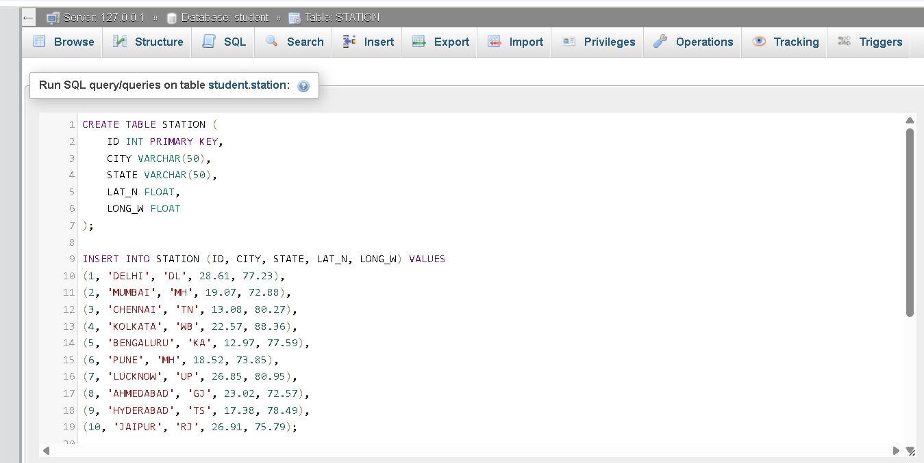

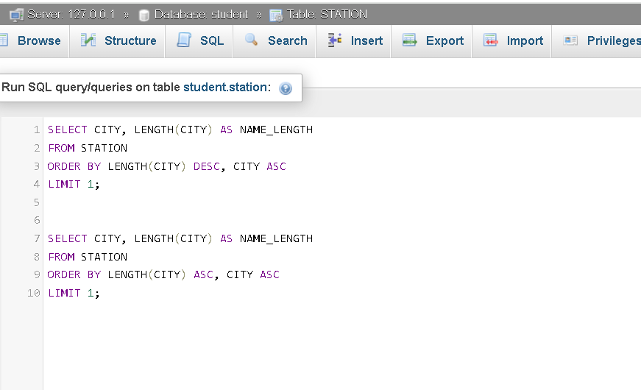

1. **Output:**

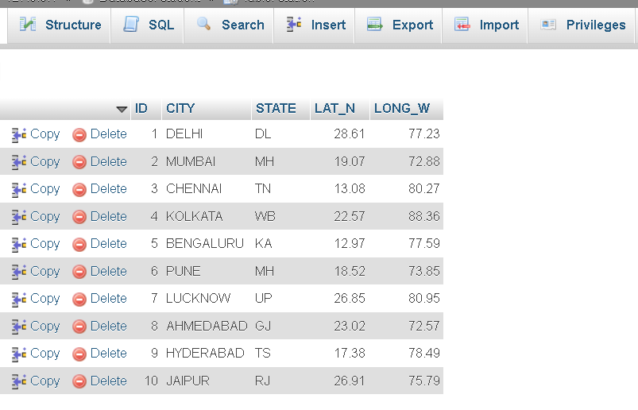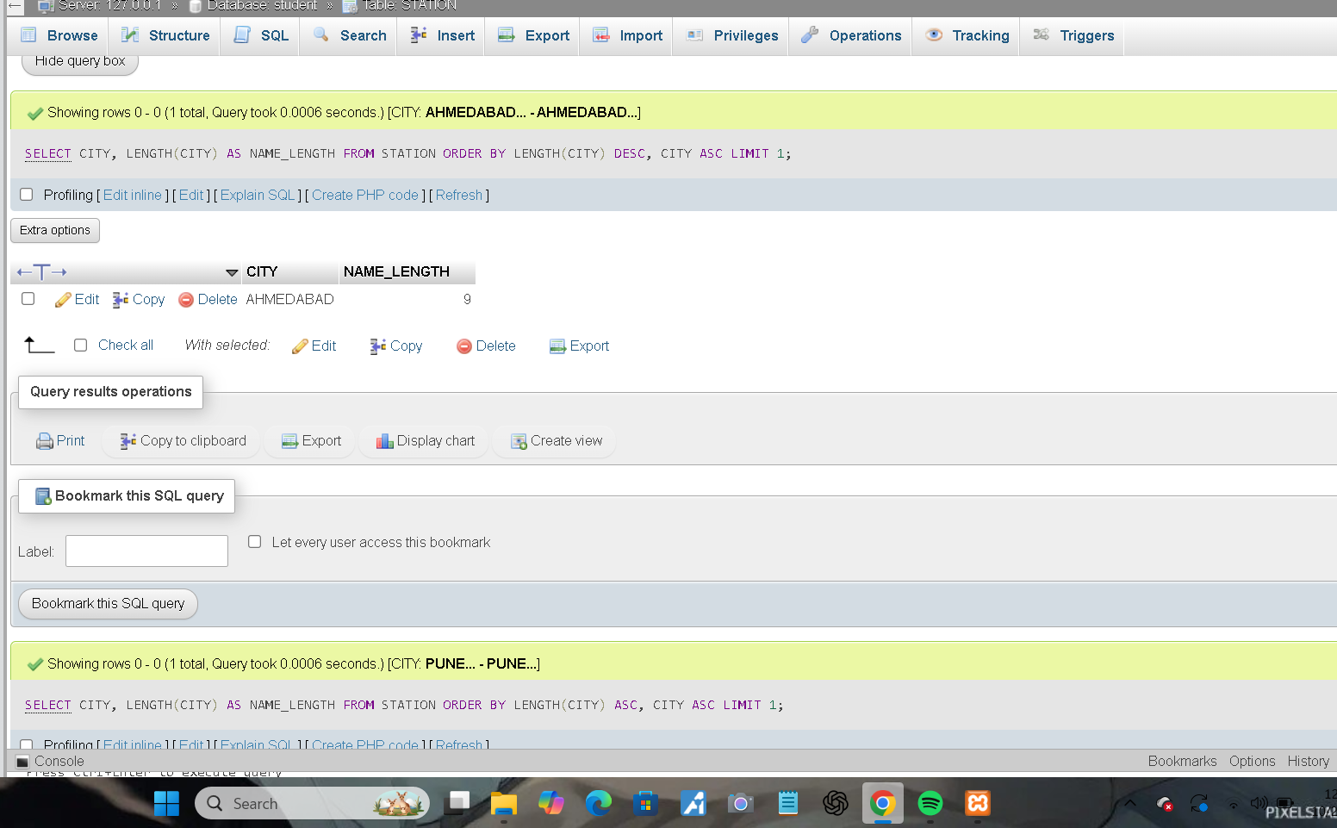

1. **Learning Outcomes: -**

* Learn to **create and manage a database** using SQL commands.
* Understand **string functions** like **LENGTH()** in SQL.
* Learn how to **sort and filter results** with ORDER BY and LIMIT.
* Practice executing SQL queries in **phpMyAdmin (XAMPP)** environment.
* Develop logical thinking for solving **query-based problems** step-by-step.